Digital Transformation: Enhancing

IoT

-

driven Solutions for Smart Islands

___________________________

**Amir**

**Vahabpour**

Researcher in Energy &

Blockchain

Email: vahabpour@ut.ac.ir



**Smart Grid, Green Energy and Energy Transition in Smart Islands**



**Amir Vahabpour**

**Education:**

* PhD Candidate – Energy Systems Engineering – Tehran University
* MSc. – Energy Systems Engineering – Sharif University of Technology ▪ BSc. – Mechanical Engineering – Khajeh Nasir Toosi University of Technology

**Professional Experience:**

* CEO at Meta-Home Company (Smart Home Solutions)



* CEO at Armaghan Kooshyaran Afrand Company (Energy Consultant)
* Former Senior Researcher at Sharif Energy Research Institute (SERI) ▪ Co-founder at Water, Environment and Energy Innovation Center (AMA)

**Areas of Interests:**

* Energy Management
* Water-Energy Nexus
* Applications of IoT and Blockchain in Energy Systems

# Overview

**Getting to know**

**renewable energies**

•

Some

facts

&

figures

•

Different

types

•

Introducing

sources

**A brief introduction**

**to smart grid**

•

Definitions

•

Essence

&

Rational

•

Benefits

•

Characteristics

**Energy transition**

**and its requirements**

•

Definitions

•

Requirements

•

Benefits

•

Actions

**Smart islands and**

**their energy pathway**

•

Challenges

•

Considerations

•

Role of REs

•

Role of SGs

•

European solution

•

American solution

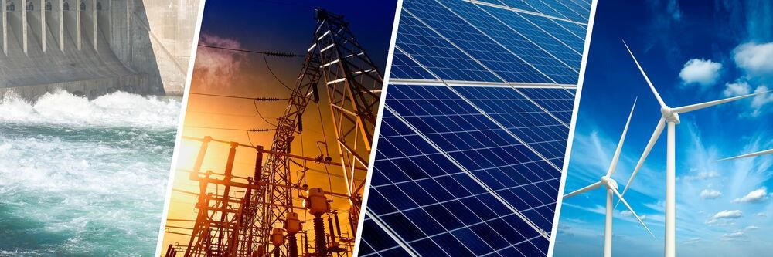**Sec 2: Renewable Energies**

# World’s renewable energy figures

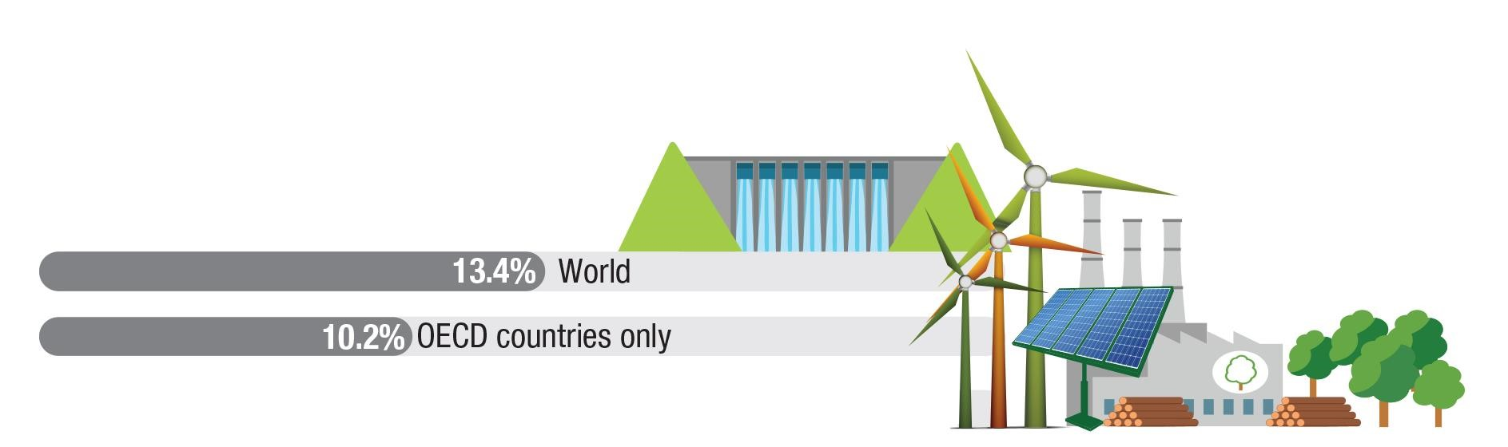● Share of energy supply from renewable resources

|  |  |  |
| --- | --- | --- |
| **Rank** | **Country** | **Percentage** |
| 1 | China | 14% |
| 2 | India | 11% |
| 3 | United States | 8% |
| 4 | Brazil | 6% |
| 5 | Nigeria | 6% |
| 6 | Indonesia | 4% |
| 7 | Canada | 3% |

Online Training Course on “Digital Transformation: Enhancing IoT driven Solutions for Smart Islands”, 18-31 July 2022

# Types of Renewable Energy

●

Major

Renewable

Resources

Wind

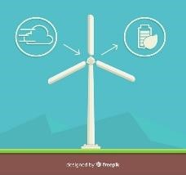

Ambient Heat

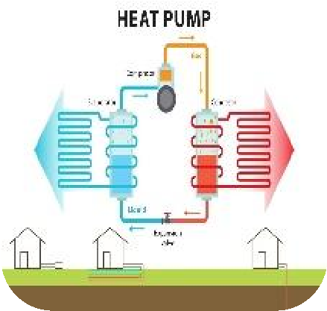

Hydro

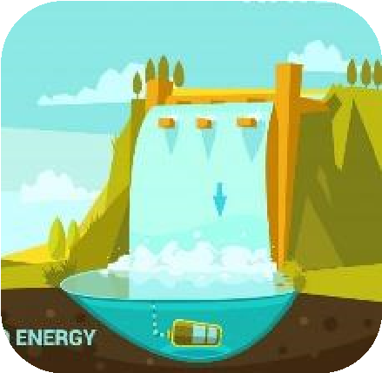

Wave

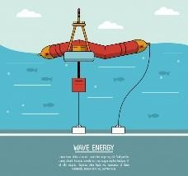

Tidal

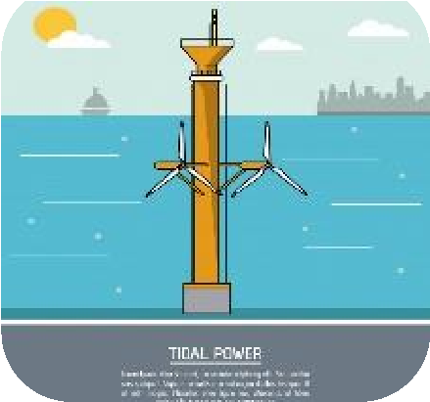

Biomass

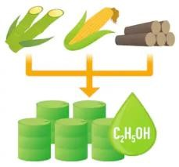

Solar

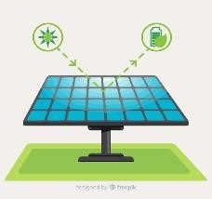

Geothermal

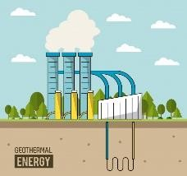

Online Training Course on “Digital Transformation: Enhancing IoT driven Solutions for Smart Islands”, 18-31 July 2022

# Types of Renewable Energy

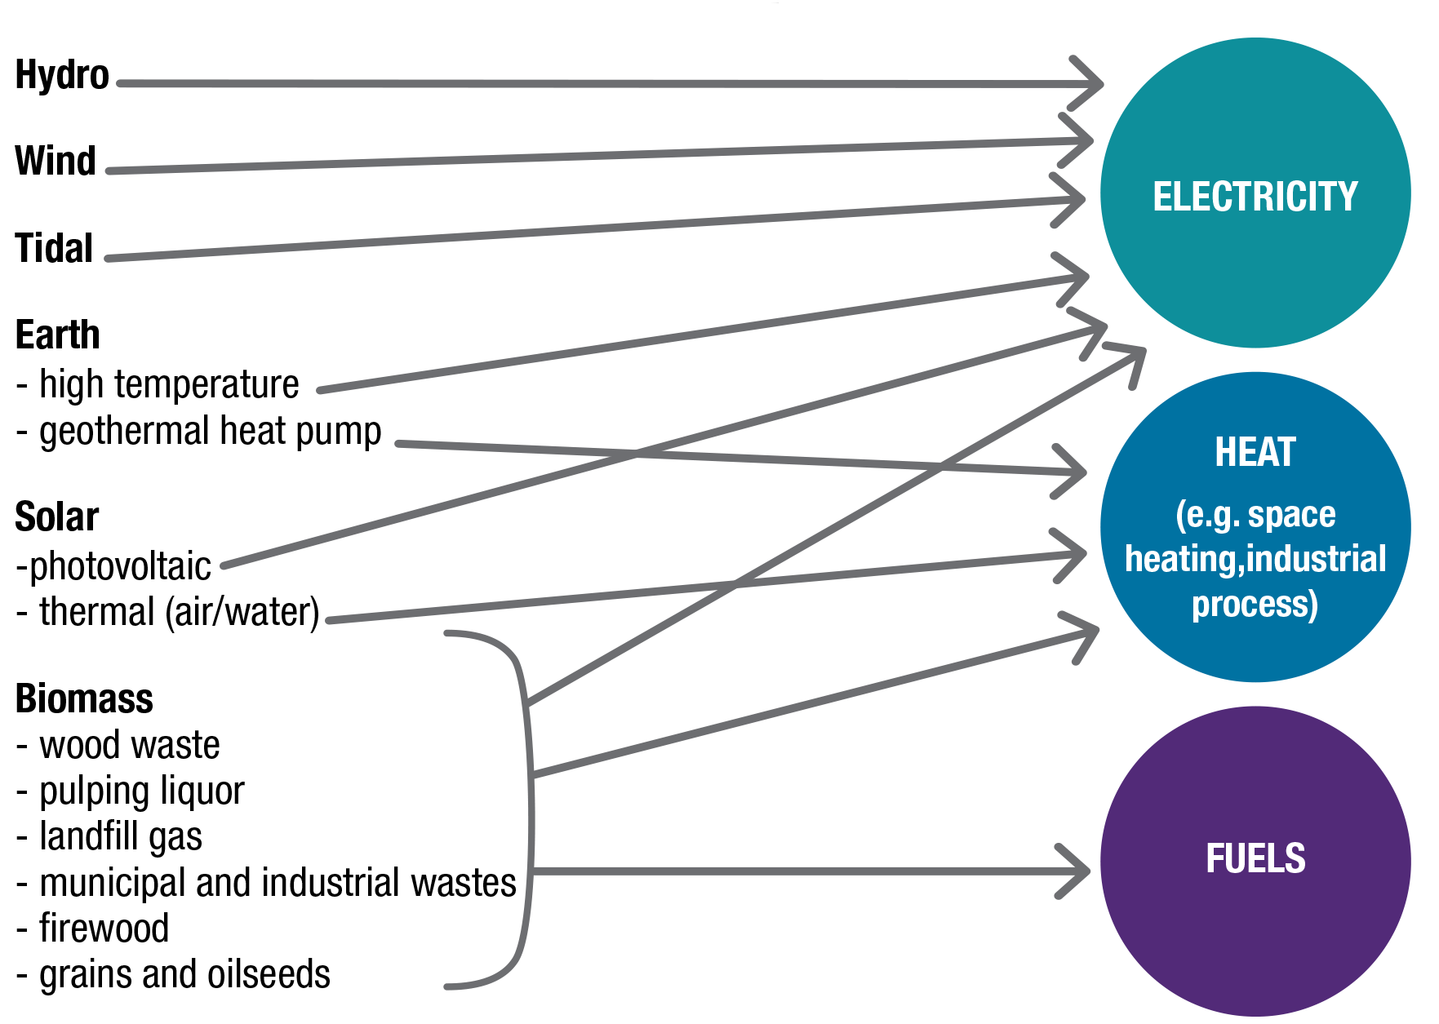● Major Renewable applications o renewable energies are majorly transformed to electricity and heat in the final use.

# Most common forms of renewable energy

● **Biomass energy:** Biomass energy is produced from nonfossilized plant materials. Wood and wood waste are the largest sources of biomass energy, followed by biofuels and municipal solid waste.

* Wood biomass includes wood pellets; wood chips from forestry operations; residues from lumber, pulp/paper, and furniture mills; and fuel wood for space heating and cooking. The largest single source of wood energy is *black liquor,* a residue of pulp, paper, and paperboard production.
* Biofuels include ethanol and *biodiesel*. Fuel ethanol is mostly produced from corn. Biodiesel is made from grain oils and animal fats.
* Municipal solid waste (MSW), or garbage, contains biomass (or biogenic) materials such as paper, cardboard, food scraps, grass clippings, leaves, wood, leather products, and nonbiomass combustible materials (mainly plastics and other synthetic materials made from petroleum). It is burned in wasteto-energy plants to generate electricity. There are also many landfills that collect and burn biogas to produce electricity.

# Most common forms of renewable energy

* **Hydropower:** Hydropower is electricity produced from flowing water. Most hydropower produced all around the world is from large dams built by governments on rivers.

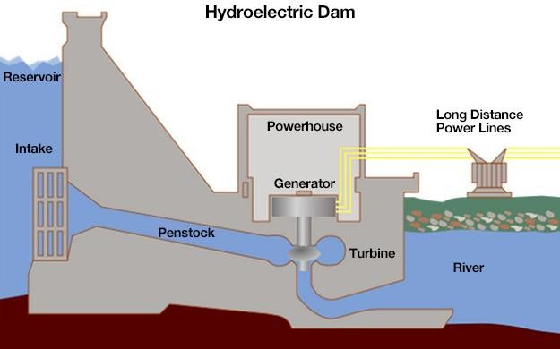

1

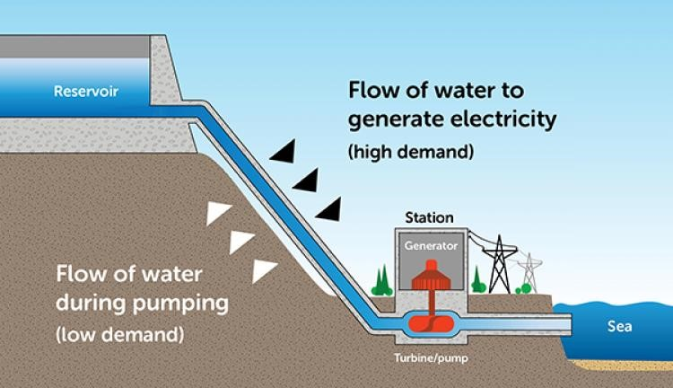

2

* There are two general types of hydropower:
  1. Conventional hydropower uses water in dams or flowing in streams and rivers to spin a turbine and generate electricity.
  2. Pumped storage systems use and generate electricity by moving water between two reservoirs at different elevations.

# Most common forms of renewable energy

* **Geothermal energy:** Geothermal energy is heat from the hot interior of the earth or near the earth's surface. Fissures in the earth's crust allow water, heated by geothermal energy, to rise naturally to the surface at hot springs and geysers. Wells drilled into the earth allow a controlled release of steam or water to the surface to power steam turbines to generate electricity. The near constant temperature of the earth near the earth's surface is used in geothermal heat pumps for heating and cooling buildings.

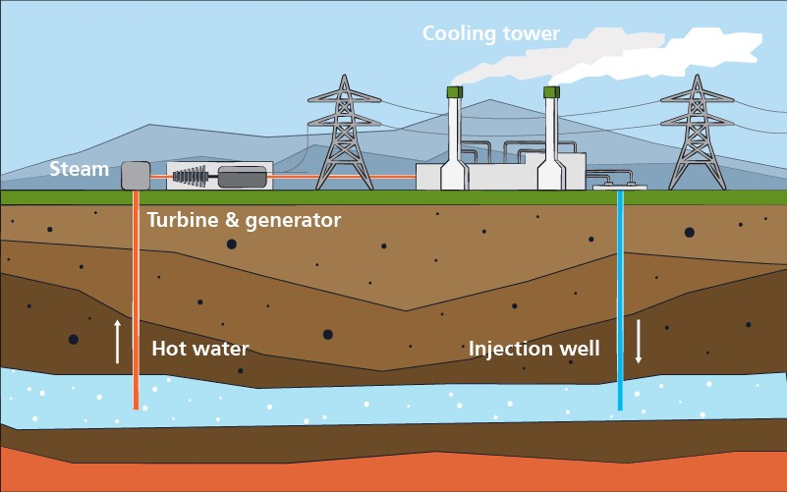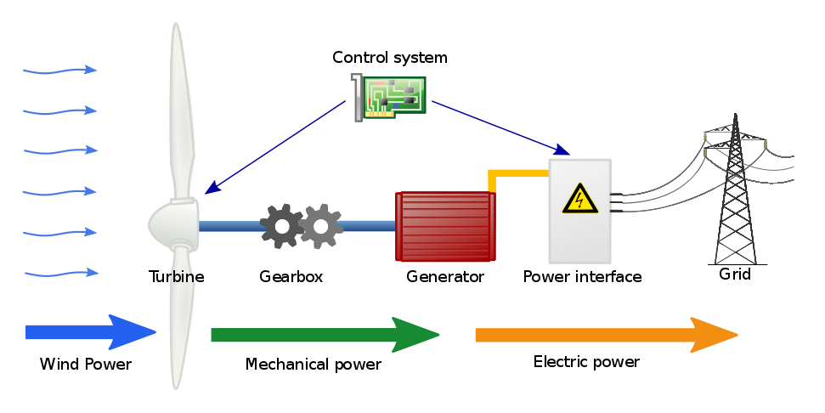

* **Wind energy:** Wind turbines use blades to collect the wind's kinetic energy. Wind flows over the blades creating lift, which causes the blades to turn. The blades are connected to a drive shaft that turns an electric generator, which produces electricity.

# Most common forms of renewable energy

● **Solar energy:** Solar energy systems use radiation from the sun to produce heat and electricity. There are three basic categories of solar energy systems:

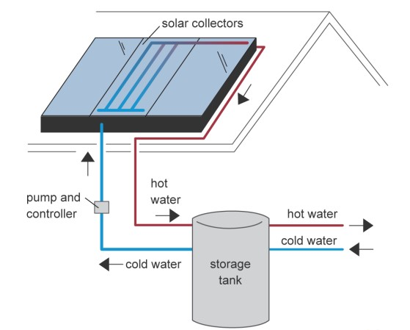

1

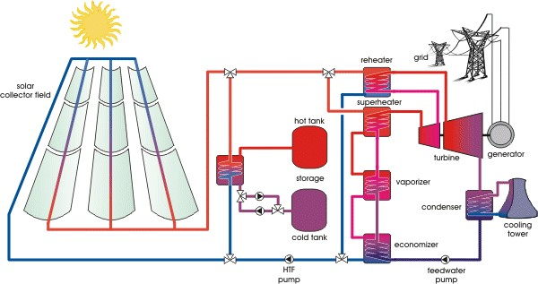

2

1. Solar thermal systems use solar collectors to absorb solar radiation to heat water or air for space heating and water heating.
2. Solar thermal power plants use concentrating solar collectors to focus the sun's rays to heat a fluid to a high temperature. This fluid generates steam to power a turbine and a generator.
3. Photovoltaic (PV) systems use solar electric cells that convert solar radiation directly into electricity. Individual PV cells are arranged into modules (panels) of varying electricity-producing capacities. PV systems range from single PV cells for powering calculators to large power plants with hundreds of modules to generate large amounts of electricity.

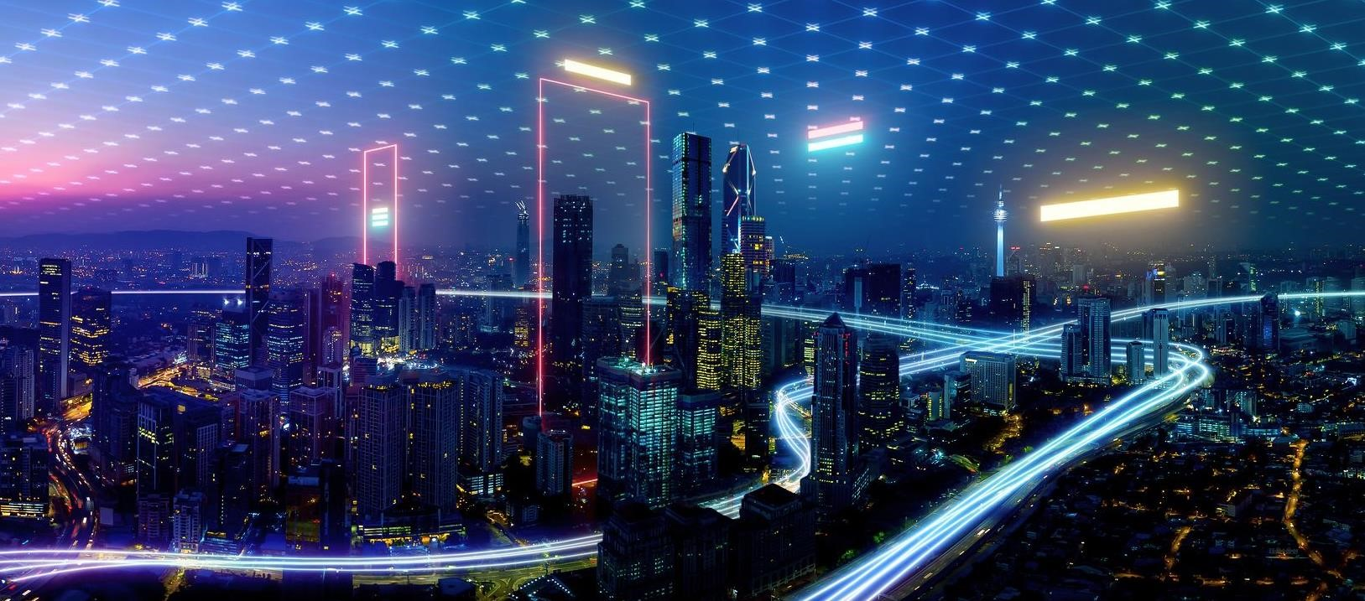

**Sec**

**2**

**:**

**Getting to know Smart Grid**

# Smart Grid Definitions

* 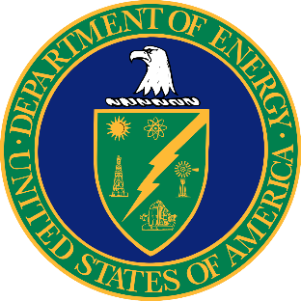The U.S. Department of Energy: “a class of technology people are using to bring utility electricity delivery systems into the 21st century, using computer-based remote control and automation. These systems are made possible by two-way communication technology and computer processing that has been used for decades in other industries. They are beginning to be used on electricity networks, from the power plants and wind farms all the way to the consumers of electricity in homes and businesses. They offer many benefits to utilities and consumers—mostly seen in big improvements in energy efficiency on the electricity grid and in the energy users’ homes and offices”.
* The International Energy Agency (IEA): “A smart grid is an electricity network that uses digital and other advanced technologies to monitor and manage the transport of electricity from all generation sources to meet the varying electricity demands of end-users. Smart grids coordinate the needs and capabilities of all generators, grid operators, end-users, and electricity market stakeholders to operate all parts of the system as efficiently as possible, minimizing costs and environmental impacts while maximizing system reliability, resilience, and stability”.



* The Korea Smart Grid Institute: “Smart Grid refers to the next-generation network that integrates information technology into the existing power grid to optimize energy efficiency through two-way exchange of electricity information between suppliers and consumers in real time”.

# The Essence of Smart Grid

* Urban areas consume up to 80% of global electricity generation
* We are in the middle of a transformation

o Decarbonization o Decentralization o Digitalization

* Sustainable Society and Smart infrastructure drives transformation of transactive grid edge* and new consumer opportunities
* Digitalization enables new services and new business models
* **Energy supply side** ● **Energy demand side** o Smart grids o Smart buildings

o Smart industries

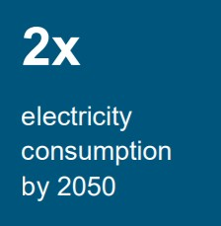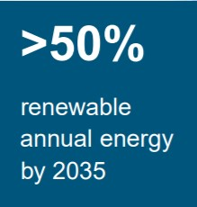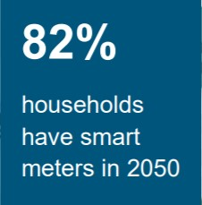

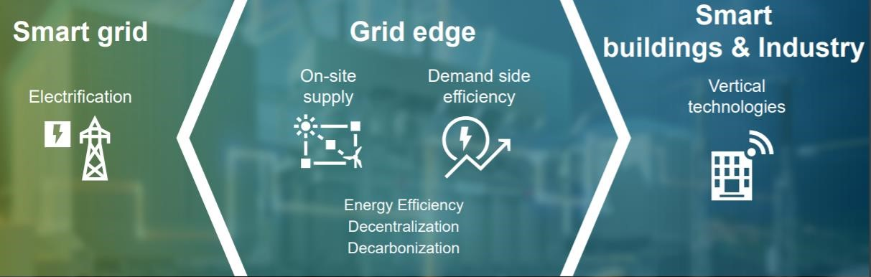

* **Grid Edge:** Innovation and disruption often play out at the boundary of grid technology toward a decentralized, distributed and transactive electric grid.

# Rationale For Smart Grid Technology

* The world’s electricity systems face a number of challenges: o ageing infrastructure o continued growth in demand o the integration of increasing numbers of variable

renewable energy sources and electric vehicles

* + the need to improve the security of supply o the need to lower carbon emissions
* Smart grid technologies offer ways not just to meet these challenges but also to develop a cleaner energy supply
  + more energy efficient o more affordable o more sustainable

# Rationale For Smart Grid Technology

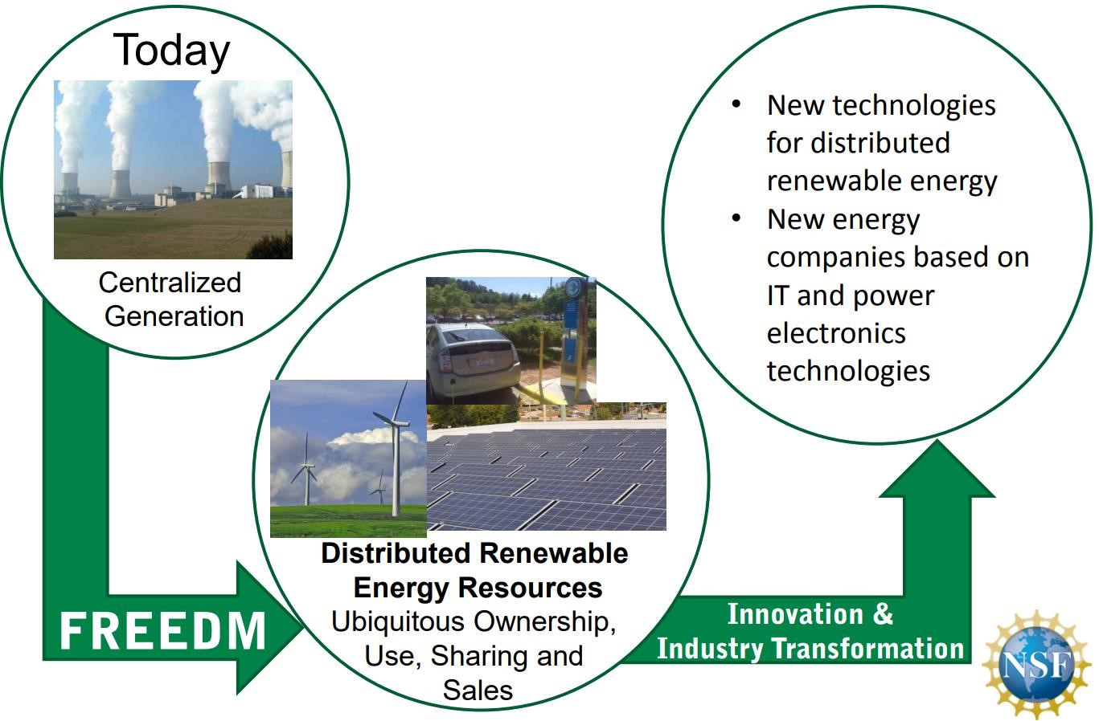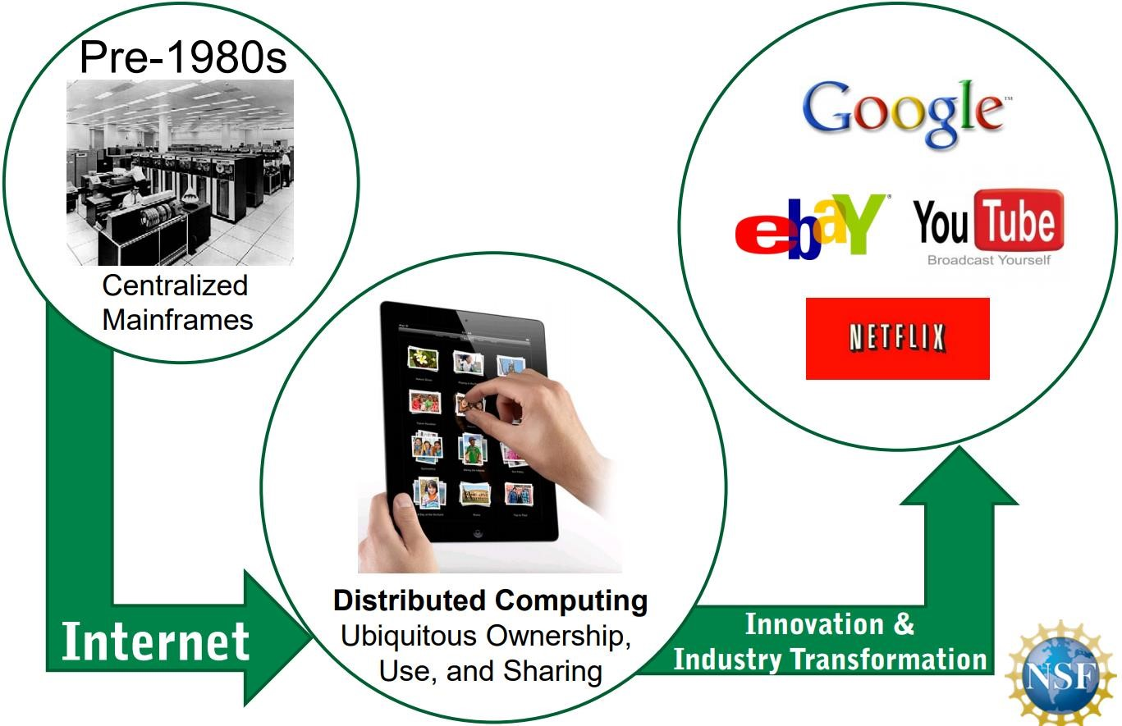

# Rationale For Smart Grid Technology

* These challenges must also be addressed with regard to each region’s unique technical, financial and commercial regulatory environment.
* 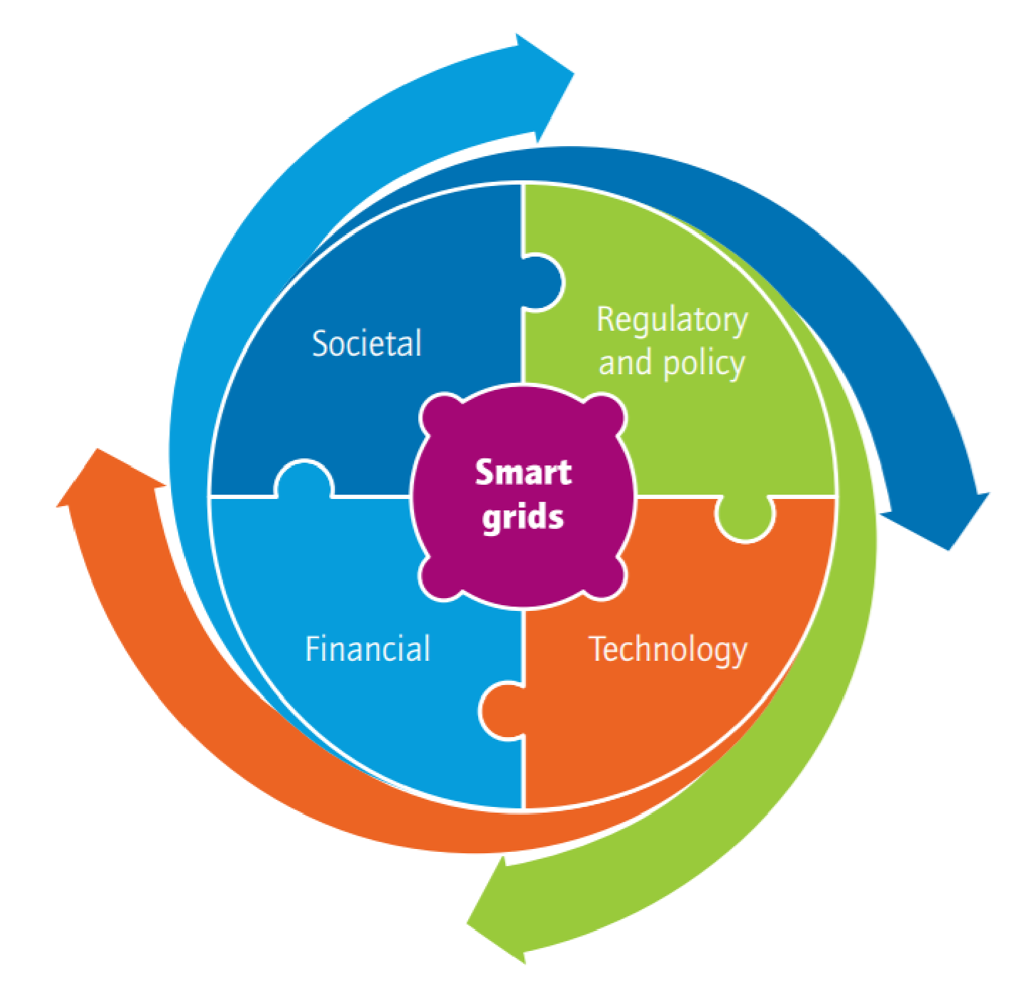Given the highly regulated nature of the electricity system, proponents of smart grids must ensure that they engage with all stakeholders, including equipment manufacturers, system operators, consumer advocates and consumers, to develop tailored technical, financial and regulatory solutions that enable the potential of smart grids.
* Smart cities and islands are exposed to a diverse set of cyber security threats and criminal misuses.
* This complex environment also presents a significant challenge for digital forensic investigations, which will invariably rely upon the data generated by the smart city components.

o To envision a secure smart city cyber security platform with access to reliable forensic evidence, due diligence for data transfer and storage in the Cloud is mandatory.

# Energy system scheme with Smart Grid infrastructure

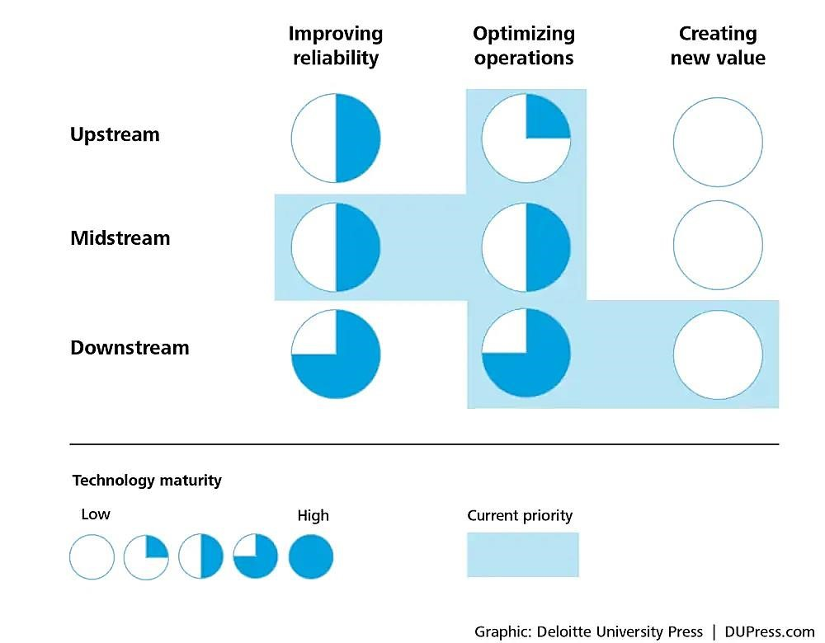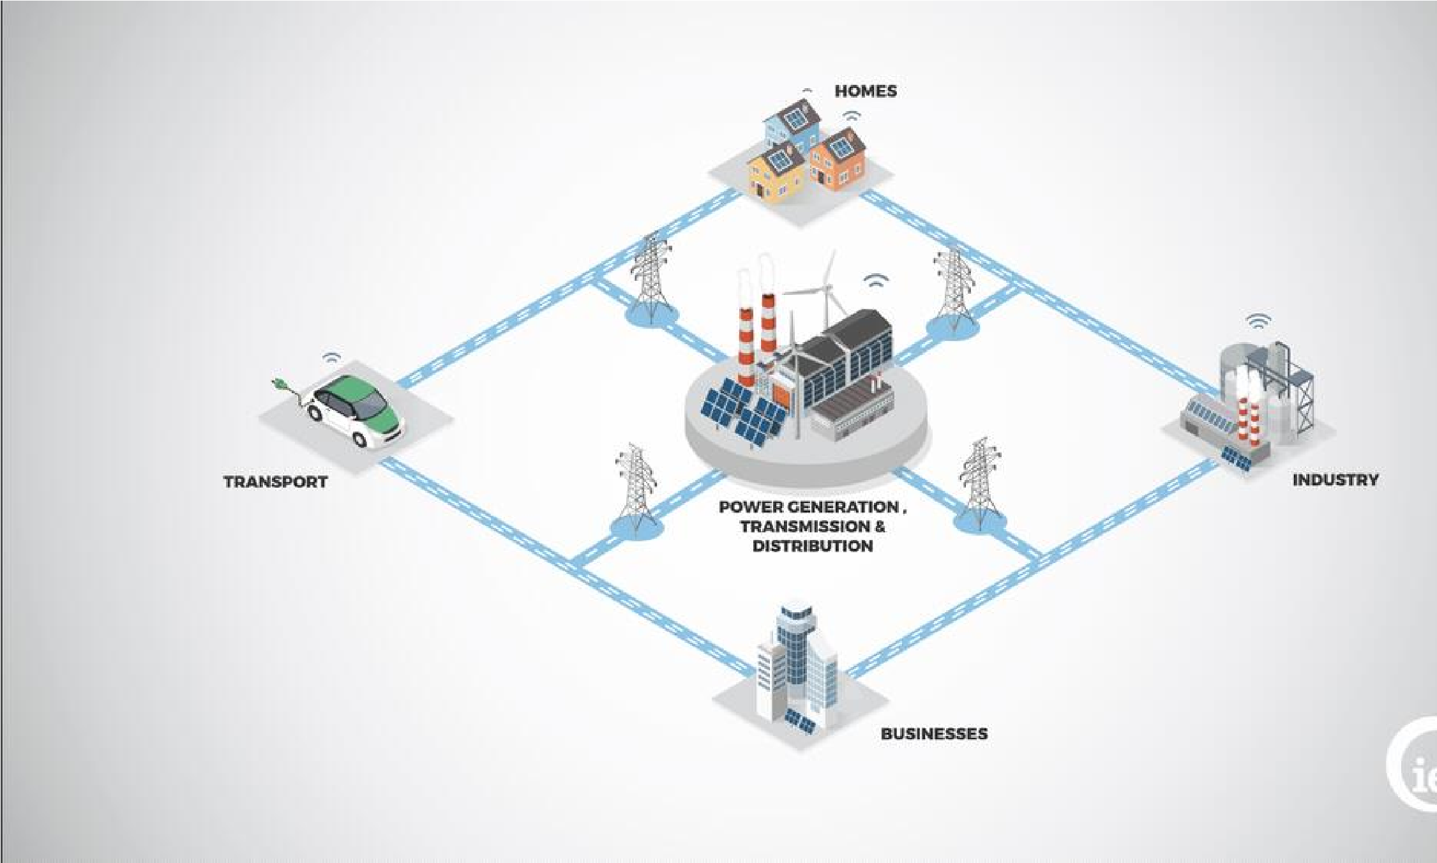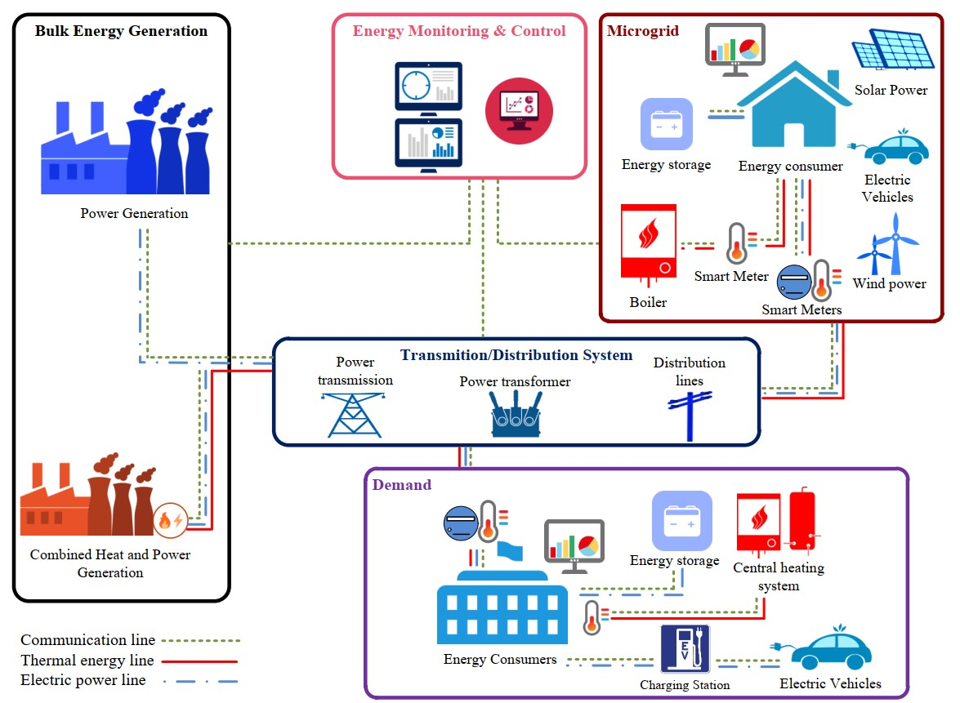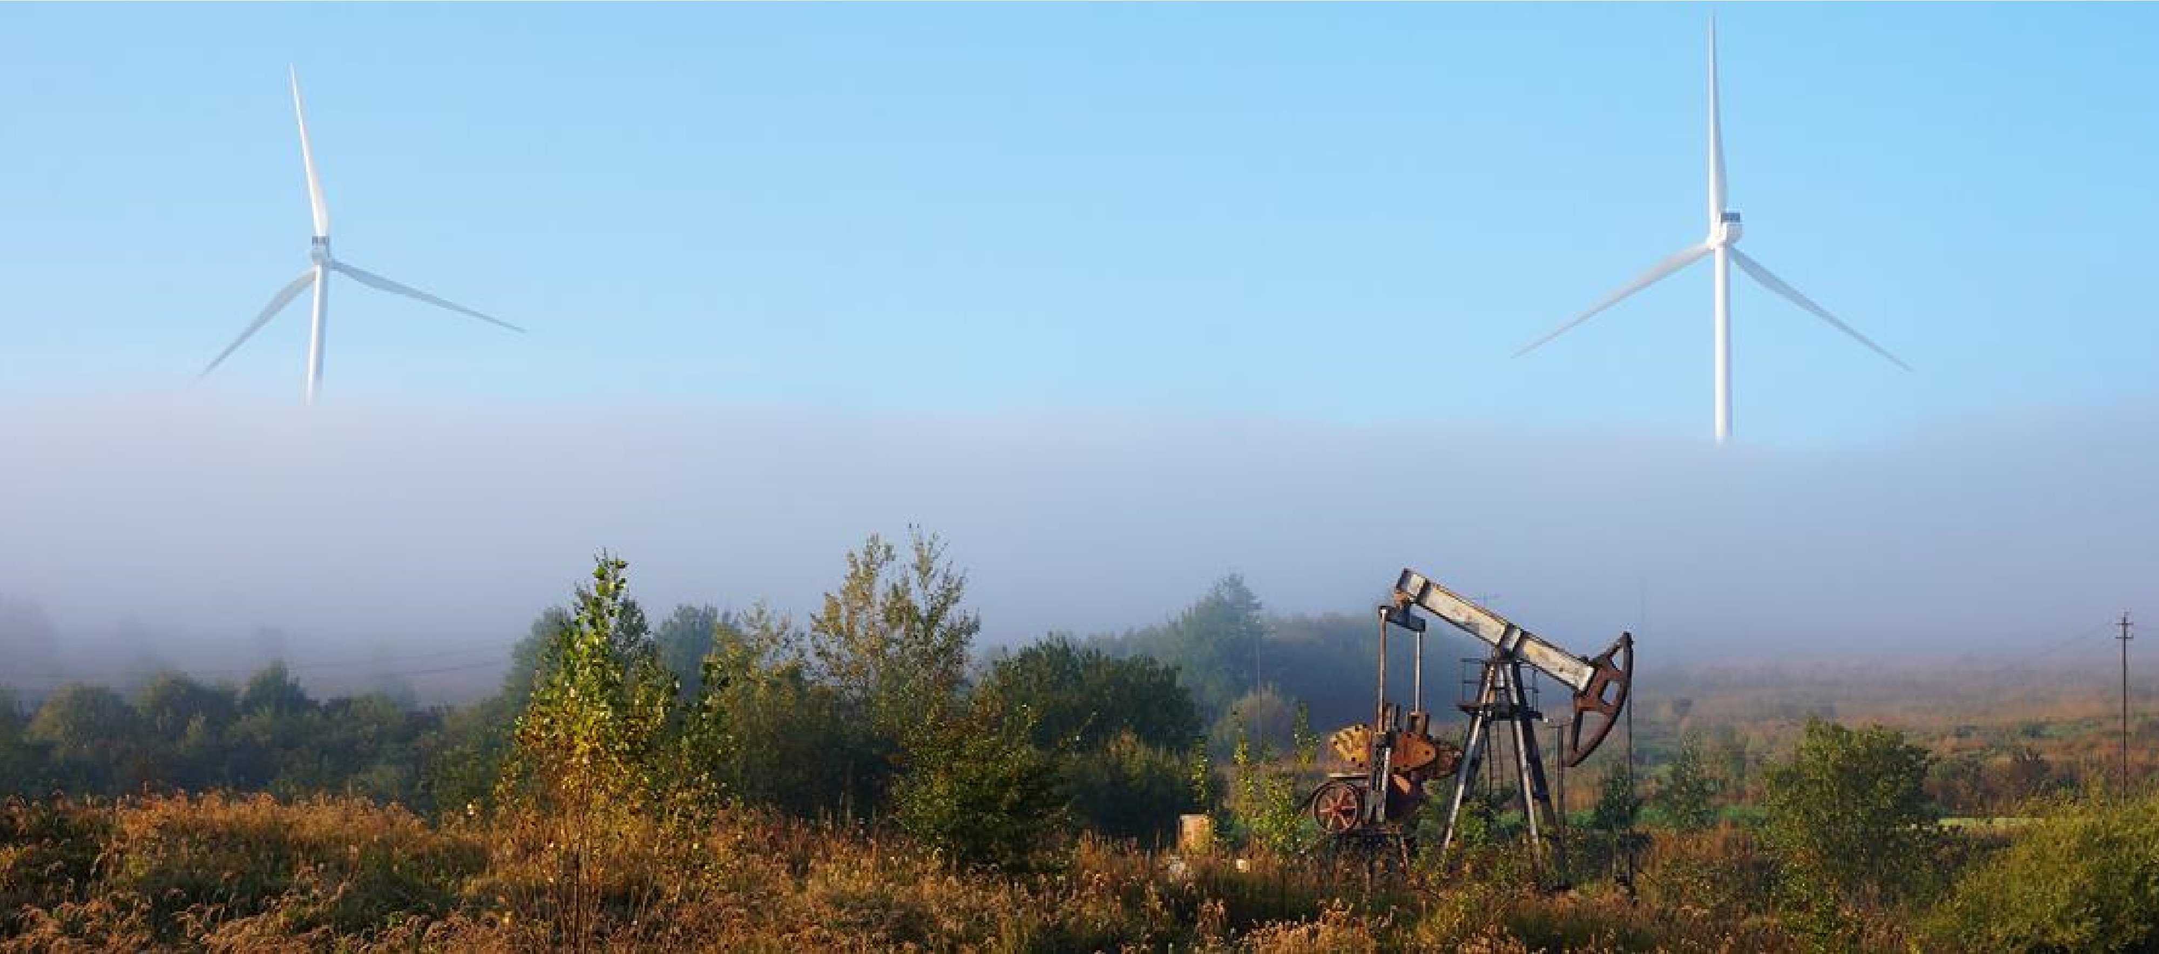

**Sec**

**2**

**:**

**Energy Transition**

**What is energy transition?**

* The Earth is heating up. According to NASA, in 2020 the planet’s average temperature was 1.02°C warmer than the baseline 1950–1980 mean.
  + 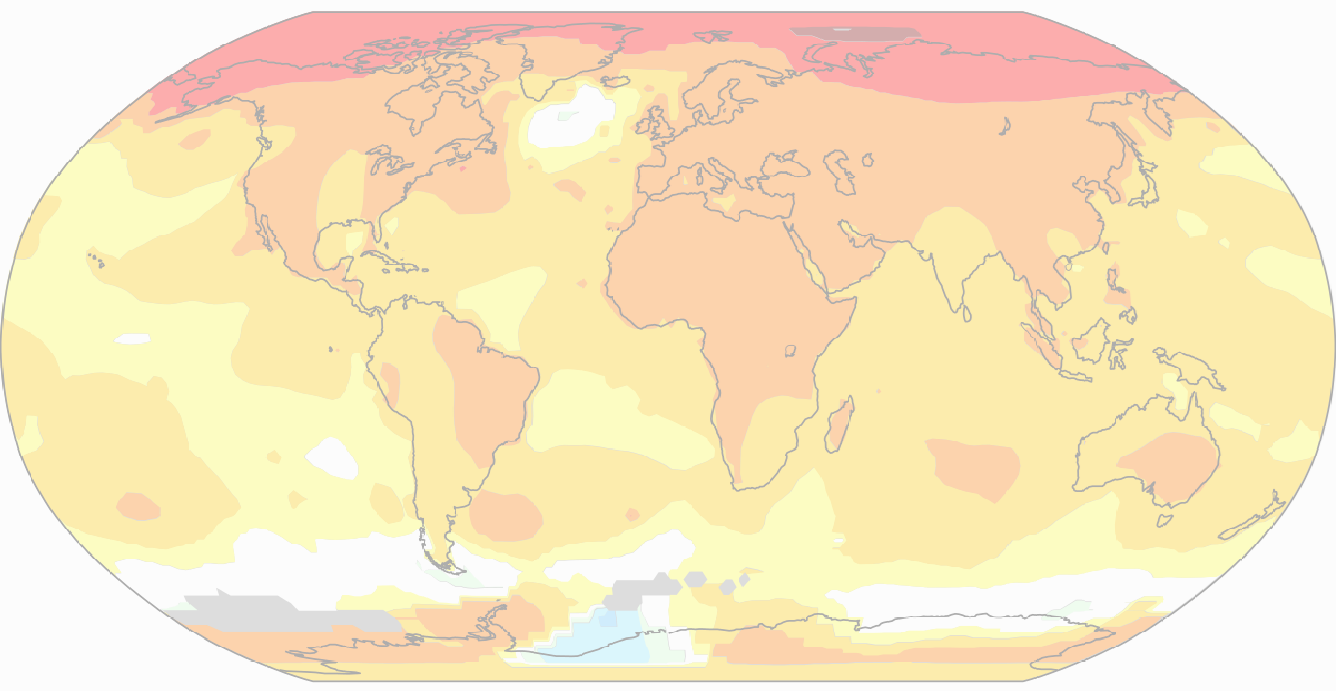**Global warming,** in addition to causing the polar ice caps to melt and sea levels to rise, is causing other **climate changes** like desertification and an increase in extreme weather events such as hurricanes, floods and fires: the distortion of the climate risks causing incalculable damage.
* The scientific community is in agreement that this is due to anthropogenic emissions of greenhouse gases into the atmosphere, especially since the Industrial Revolution.
  + The main such gas, carbon dioxide, originates largely from the energy sector (including but not limited to the generation of electricity).
* In December 2015, at COP 21 in Paris, an international agreement was signed that set the target of limiting global warming by the end of this century to below 2°C compared with pre-industrial levels and preferably limiting it to 1.5°C.

COP26, which took place in November 2021 in Glasgow, confirmed the commitment to achieve carbon neutrality by 2050.

**What is energy transition?**

* The energy transition is a pathway toward transformation of the global energy sector from fossil-based to zerocarbon by the second half of this century.
* 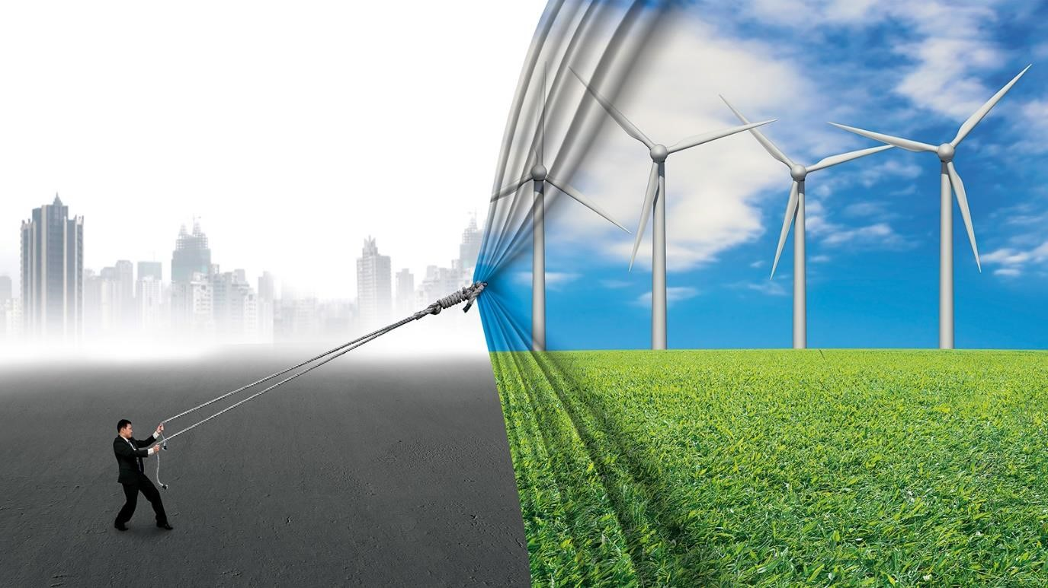At its heart is the need to reduce energy-related CO2 emissions to limit climate change.
* Decarbonisation of the energy sector requires urgent action on a global scale, and while a global energy transition is underway, further action is needed to reduce carbon emissions and mitigate the effects of climate change.
* Renewable energy and energy efficiency measures can potentially achieve 90% of the required carbon reductions.

## Requirements of energy transition

* In order to achieve this goal, our main tool is the energy transition:

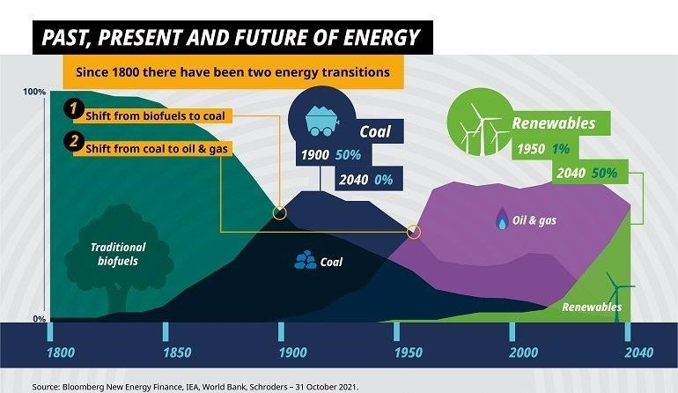o The shift from an energy mix based on fossil fuels to one that produces very limited, if not zero, carbon emissions, based on renewable energy sources.

* A huge contribution to decarbonization comes from the electrification of consumption, replacing fossil fuel-generated electricity with energy generated from renewable sources, which also makes other sectors like transport cleaner; the digitalization of networks also contributes by improving energy efficiency.

## Benefits of energy transition

* The energy transition is not only limited to the gradual closure of coal-fired power stations and the development of clean energies: it is a paradigm shift that concerns the entire system.
* 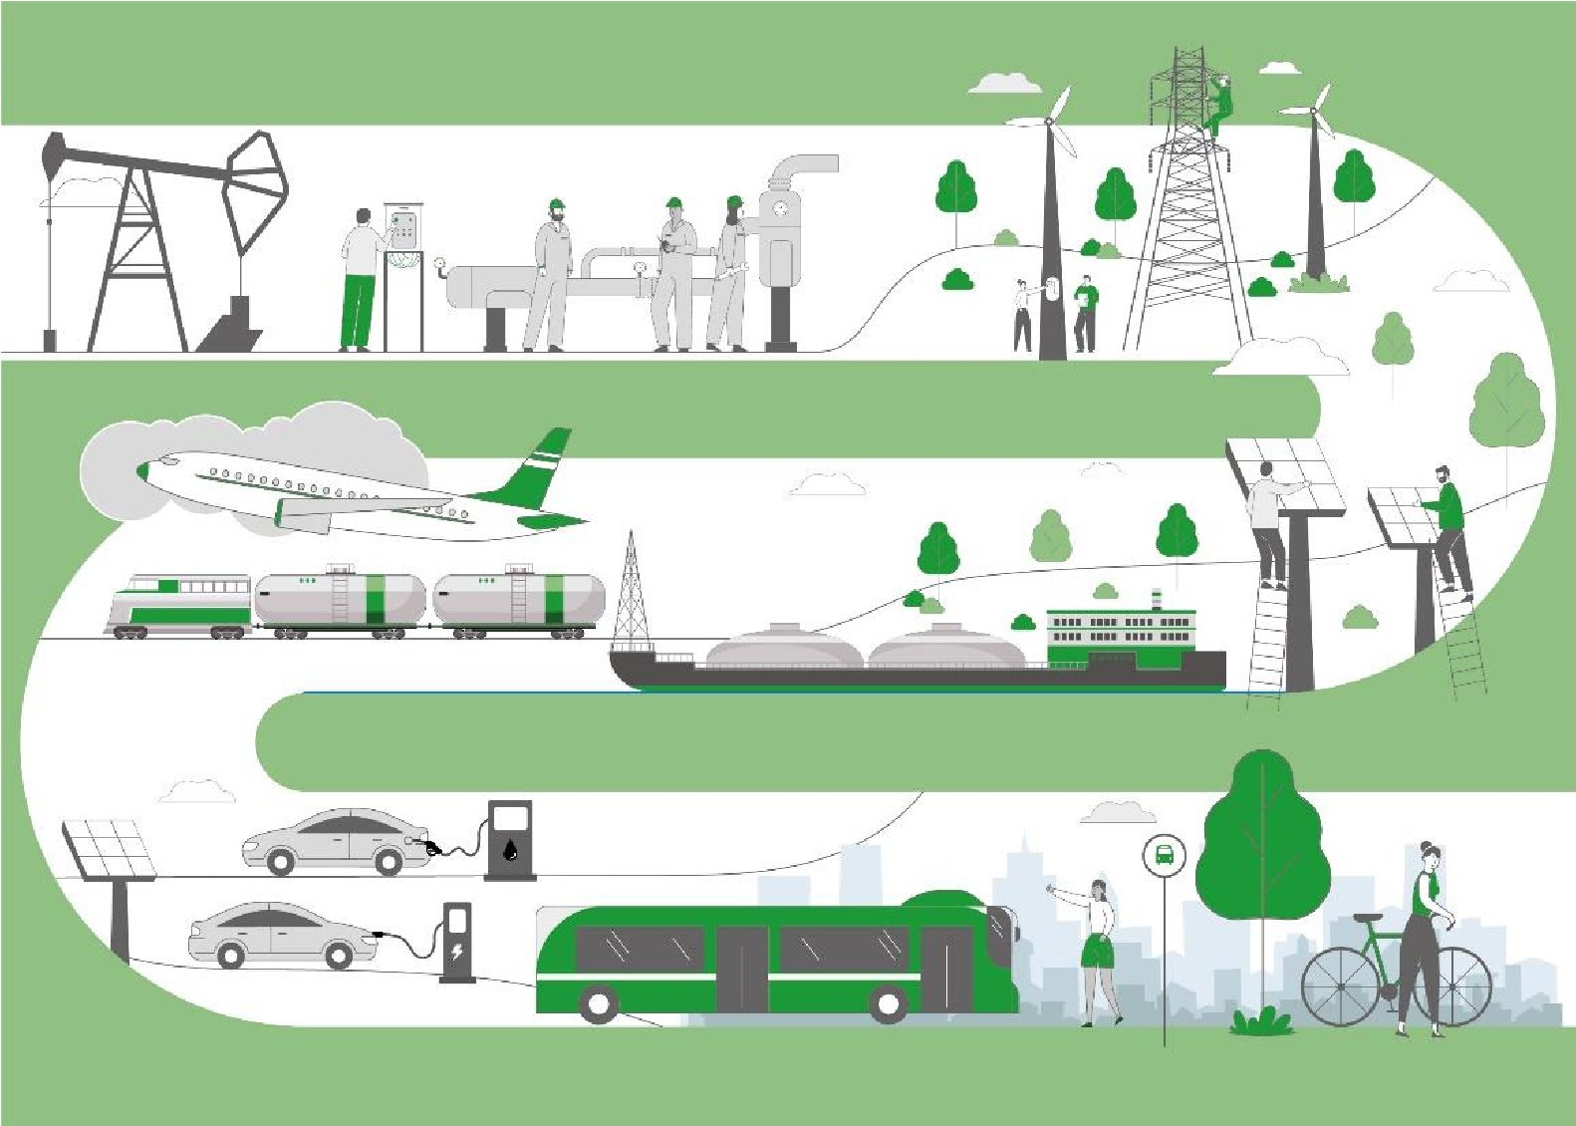This solution can provide benefits not only for the climate but also for the economy and for society. The digitalization of electricity grids can lead to the age of smart grids and open the way for new services for consumers.
* From the environmental perspective, renewable sources and electric mobility reduce pollution, while coal-fired power stations can be repurposed in line with the principles of the circular economy.
* Concerning social sustainability, the new jobs created can absorb those people previously working in the thermoelectric sector. It is important that the energy transition be inclusive and ensure that no one is left behind.

## Actions towards energy transition

● Renewables now make up the majority of annual power capacity additions:

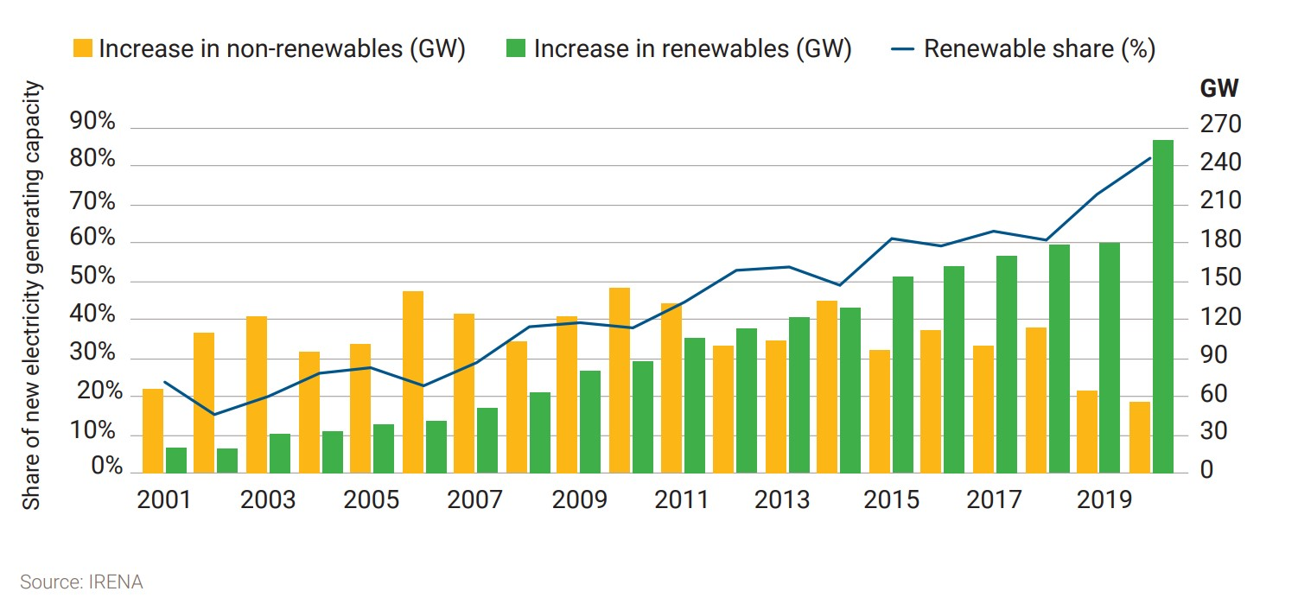

## Actions towards energy transition

● Automakers leaving internal combustion engine market:

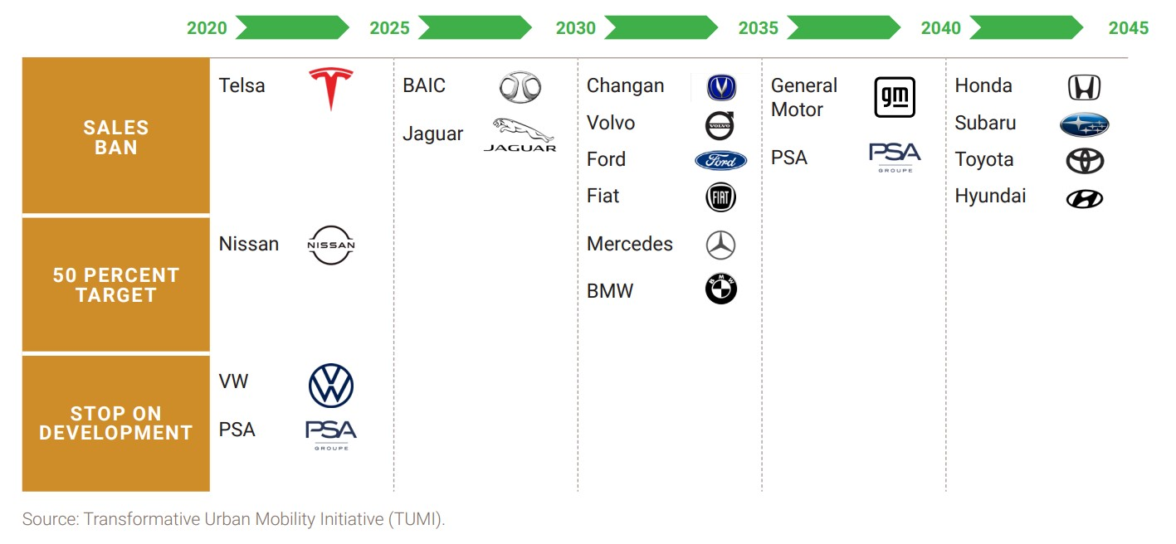

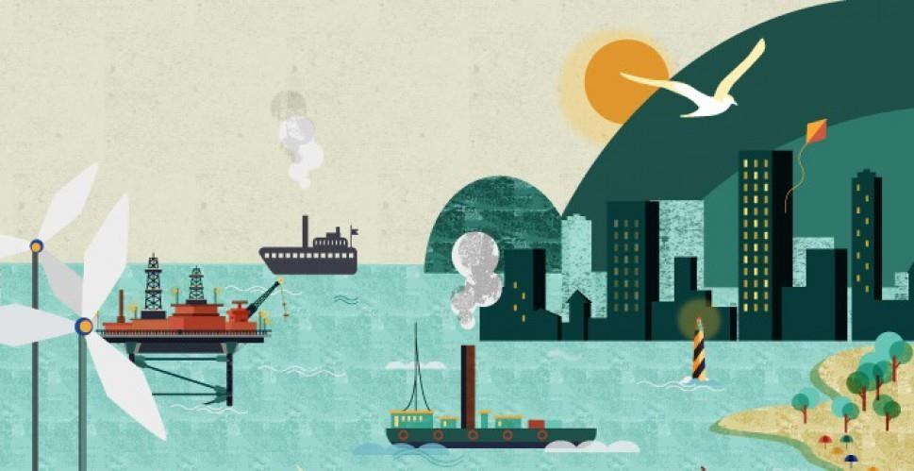

**Sec**

**4**

**:**

**Energy Transition in Smart Islands**

## Smart Islands: New Solutions

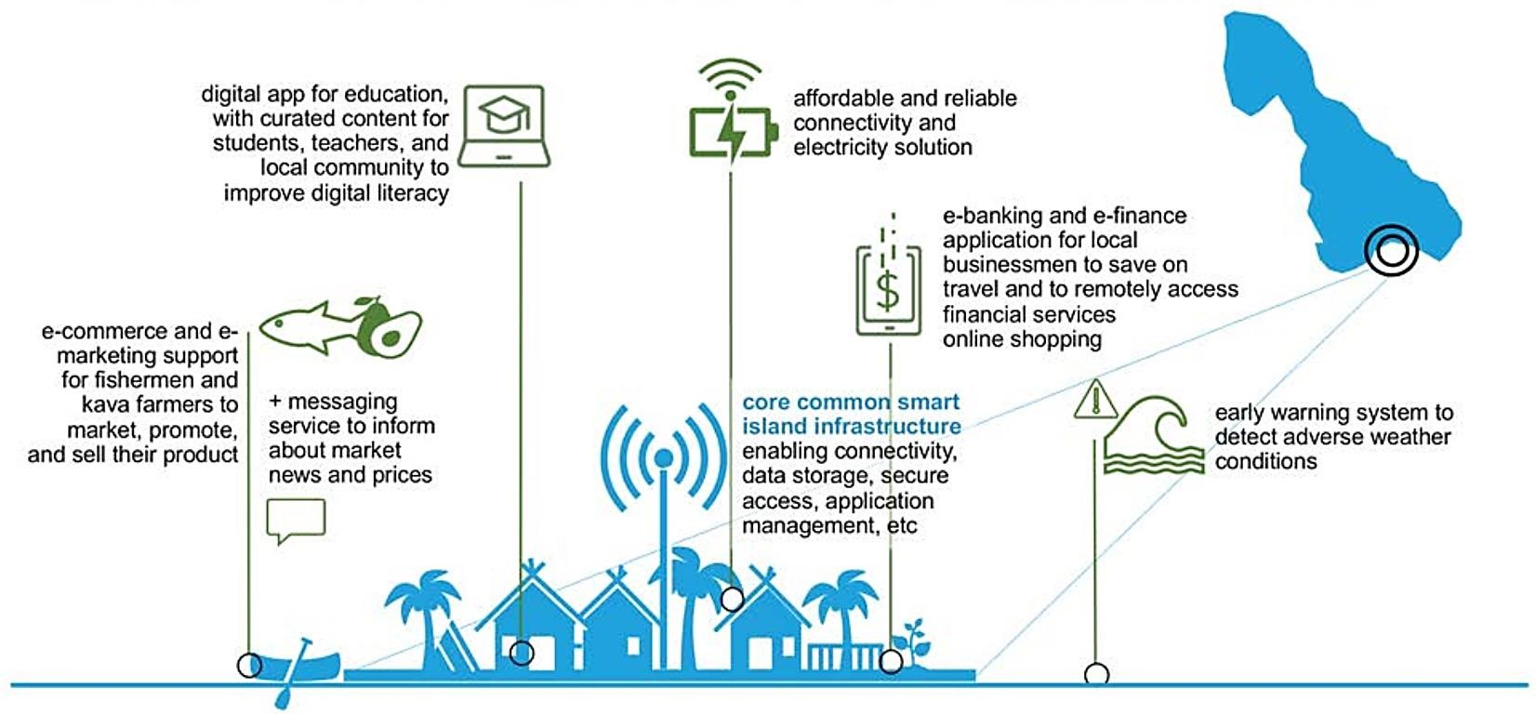

## Challenges of islands’ energy supply

* Islands typically have sensitive energy systems depending on natural surroundings, but innovative technologies and the exploitation of renewable energy (RE) sources present opportunities like self-sufficiency, but also challenges, such as grid instability.
* 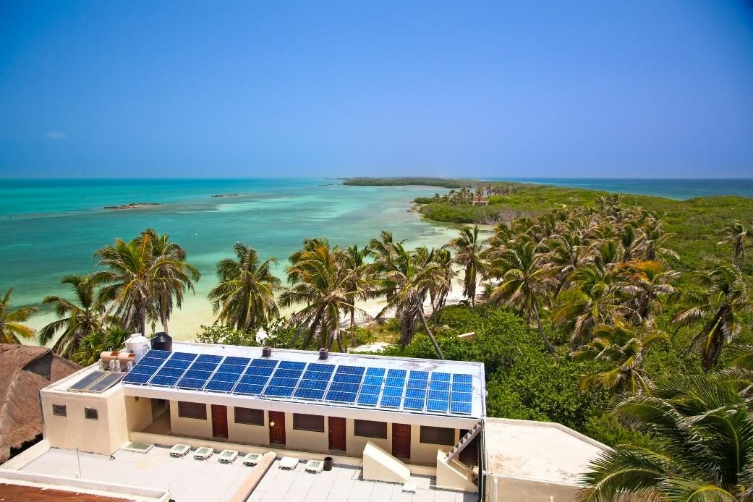Islands are under more pressure than mainlands due to their inherent isolation and higher dependence on their natural surroundings, including conditions affecting possible RE utilization.
* Islands face exorbitant electricity costs when importing fossil fuels and are also among the most vulnerable regions to rising sea levels, drought and flooding.
* Innovative teamwork is putting them on the fast track to 100% energy independence – the green way

## Energy considerations of the islands

* self-reliant islands and remote communities development of resilient energy systems
* Island and remote communities have unique physical features that impact energy systems.
* For many of these communities, access to resilient, affordable, sustainable, and clean energy resources is a priority.
* 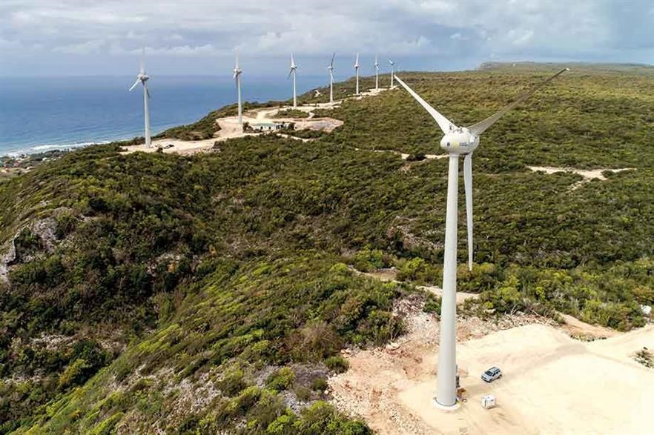The Pacific, and the surrounding areas, have some of the world’s highest electricity prices in the world.
* Like many islands around the globe, the featured islands are heavily reliant on fossil fuels for electricity generation, leaving them vulnerable to global oil price fluctuations that directly impact the cost of electricity.

## Providing an island with smart grid

* Smart grids are energy networks monitor energy flows and adapt the changes in energy supply and demand accordingly.
* 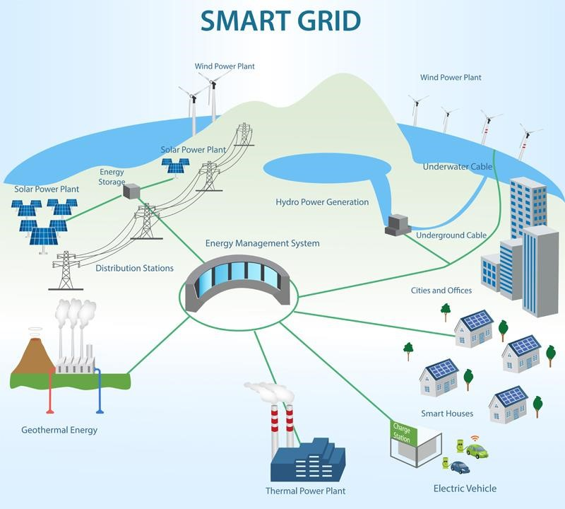When connected with smart metering systems, smart grids provide consumers and suppliers information on real-time consumption.
* With smart meters, consumers can adapt – in time and volume – their energy usage to different energy prices throughout the day, saving money on their energy bills by consuming more energy in lower price periods.
* The scale of these pilot projects enables to test the different components and systems in the field in vigorous environmental and operational conditions, while reducing the impacts of possible failures of integrating these systems into an existing infrastructures.

## Renewable energy for islands

* These small pieces of land surrounded by water are taking advantage of their geographical features to install renewable energies and accelerate their sustainable development.
* 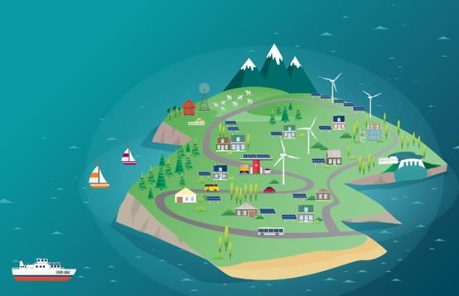For increasing their security, the islands prefer to use indigenous sources as renewable ones; unfortunately, the intermittence and stochastic character of these “fatal” energy sources make them more difficult to manage and it is aggravated in the case of small island networks.
* This transition away from imported, carbon-dense fuel could improve local economic and ecological resilience, reduce electricity prices, and dramatically reduce per capita carbon emissions.

## Renewable energy for islands

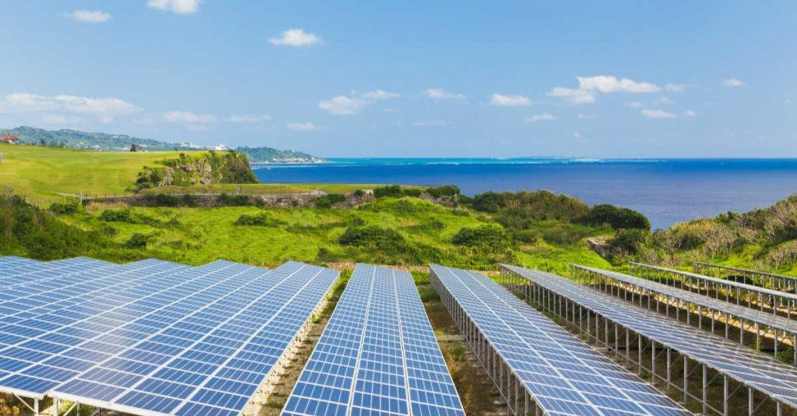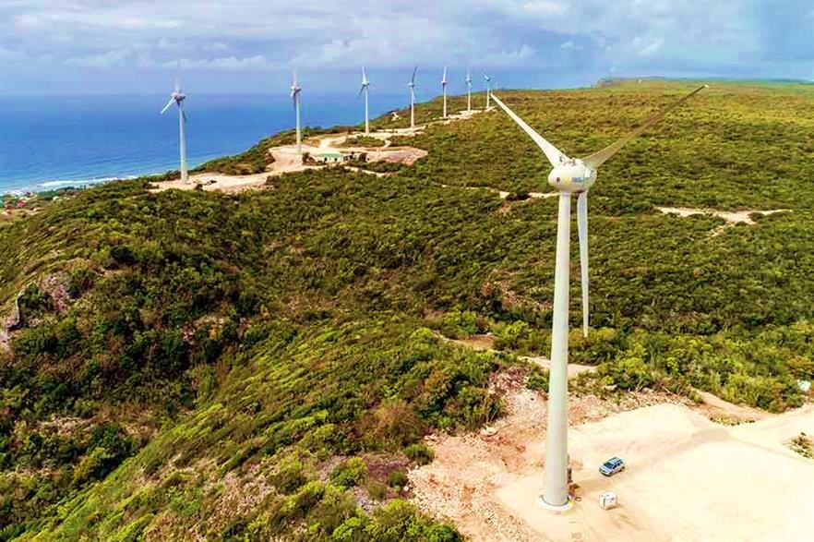

* Many islands have access to abundant **wind and solar** energy resources and could significantly cut ties with the fossil fuel industry.
* **Hydropower** can be developed on mountainous islands where it often rains (and which have a large amount of rainfall).
* **Biofuels** derived from coconut, palm or sweet sorghum oils would enable local economies to thrive and reduce dependence on fossil fuel imports, helping islands to be sustainable.
* **Algae** – even though these are still in an early stage of development – can bring great benefits to island communities for their fuel production.
* **Ocean energy** from the action of **tides, waves** are other remarkable renewable resources for islands.

## Smart sustainable energy system for the islands

**Some**

**of**

**the**

**suggestable**

**technological**

**solutions**

**to**

**be**

**investigated**

**according**

**to**

**relevant**

**pillars**

**for**

**an**

**island**

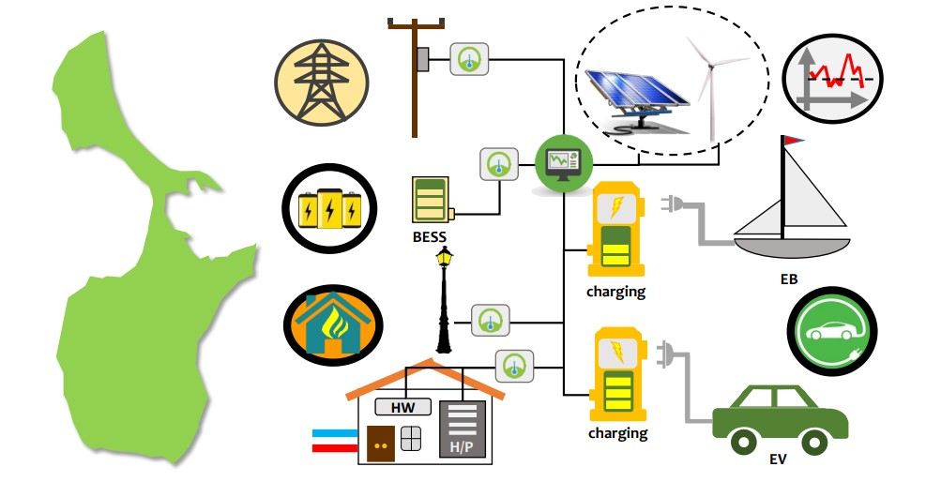

## The Smart Islands Energy System (SMILE)

* 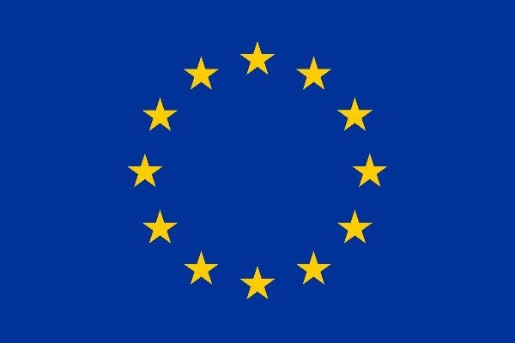This project was a collaboration of nineteen partners from various European countries and is funded by the European Union’s ‘Horizon 2020 research and innovation program.
* The project demonstrated nine different smart grid technologies on three different islands. The end goal of the project was to promote the market introduction of these nine technologies.
* 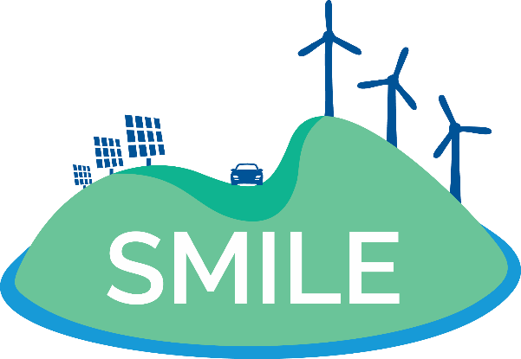The scale of these pilot projects enabled to test the different components and systems in the field in vigorous environmental and operational conditions, while reducing the impacts of possible failures of integrating these systems into an existing infrastructure.

## SMILE thematic pillars

**Demand Response (DR)** services with the use of predictive algorithms are proposed and tested in the most appropriate scheme for each pilot

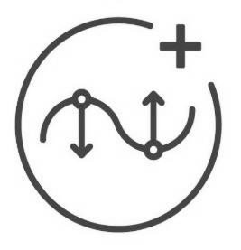

**Smartening the Distribution Grid**

through

advanced monitoring and predictive models

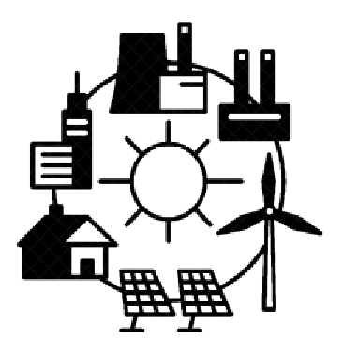

|  |  |  |  |  |  |  |
| --- | --- | --- | --- | --- | --- | --- |
|  |  | **Energy storage** provided with the use of BESS or heating storage, and storage management through models and algorithms |  |  |  | **Smart Integration of grid users from Transportation**, using the flexible capacity of electric vehicles and boats |

**Domestic heating/cooling systems**, using renewable technologies coupled with energy/heat storage options



## SMILE pilot projects

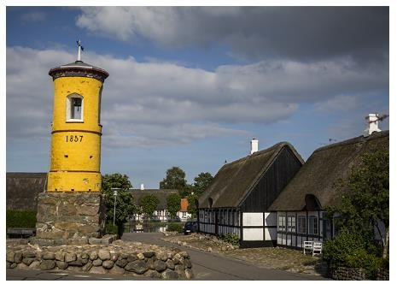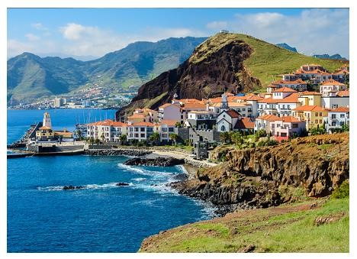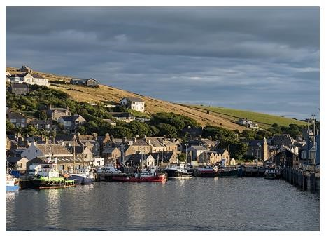

**Samsø**

(Denmark) ● In order to facilitate the transition, the SMILE project implemented three large-scale pilot projects in different regions of Europe with similar topographic characteristics but different policies, regulations and energy markets.

**Orkney Islands**

* The objective is to test solutions while establishing mutual learning (UK) processes and providing best practice guidance for replication in other regions.
* The three pilots will test different combinations of technological solutions according to local specificities and conditions and the **Madeira** existing infrastructure. (Portugal)

## Europe’s local-to-global energy transition strategy

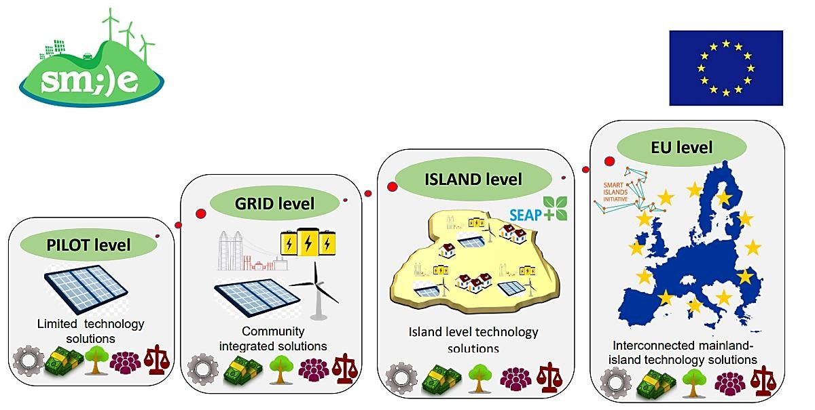

## Energy Transition Initiative

* The U.S. Department of Energy's (DOE) Energy Transitions Initiative Partnership Project (ETIPP) works alongside remote, island, and islanded communities seeking to transform their energy systems and increase energy resilience through strategic energy planning and the implementation of solutions that address their specific challenges.

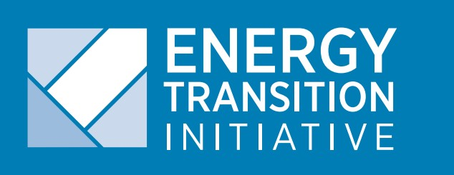

* The Energy Transitions Initiative (ETI) provides a proven framework and technical resources and tools to help islands, states, and cities transition to a clean energy

economy and achieve their clean energy goals.

**Remote** communities **Island** communities

* are isolated from population centers • are isolated from the mainland by and as a result, have limited access to waterways. centralized energy systems.

**Islanded** communities

* are not grid-tied to large transmissionscale power systems and as a result, experience frequent issues with power quality or reliability.

## Energy Transition Initiative

To watch the video of this slide, refer to the video presentation.



## Case Study: Hawaii island

* After initially setting a goal of 70% clean energy by 2030 by ETI, Hawaii further chose a more ambitious target in 2015 by setting a goal of 100% renewable electricity by 2045.
* Hawaii has set the most aggressive clean energy goal in the U.S., requiring 100% renewable electricity by 2045.
* Hawaii is already much further along in its clean energy goals than most states, with the share of customers hosting solar photovoltaic systems being about 20 times greater than that of an average U.S. utility.
* 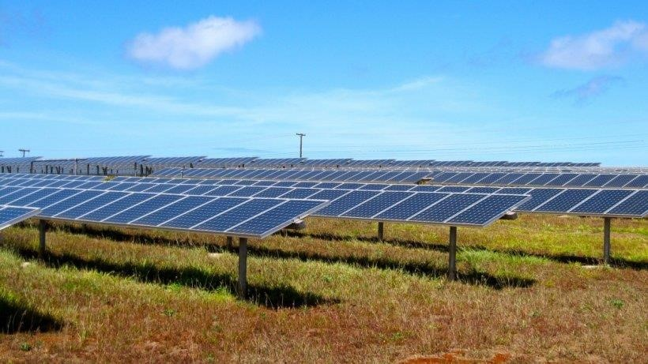The National Renewable Energy Laboratory has collaborated with one of America’s largest solar installers, SolarCity, to examine ways for PV systems to better interact with the grid. The work pointed the way for Hawaiian Electric Company to allow more PV systems to be installed.
* ETI is providing training to the Hawaii Public Utilities Commission to help the staff deal with an increasing number of dockets related to renewable energy.

